**Supplementary Figures and Tables**

***Copy number variations shape genomic structural diversity underpinning ecological adaptation in the wild tomato Solanum chilense***

Kai Wei1,2*, Remco Stam3, Aurélien Tellier2*, Gustavo A Silva-Arias2,4*

1Xinjiang Key Laboratory of Biological Resources and Genetic Engineering, College of Life Science and Technology, Xinjiang University, 830049, Urumqi, China

2Professorship for Population Genetics, Department of Life Science Systems, School of Life Sciences, Technical University of Munich, Liesel-Beckmann Strasse 2, 85354 Freising, Germany

3Department of Phytopathology and Crop Protection, Institute of Phytopathology, Faculty of Agricultural and Nutritional Sciences, Christian Albrechts University, Hermann Rodewald Str 9, 24118, Kiel, Germany

4Instituto de Ciencias Naturales, Facultad de Ciencias, Universidad Nacional de Colombia, Sede Bogotá, Av. Carrera 30 # 45-03, 111321, Bogotá, Colombia

*Corresponding authors: Kai Wei: [kaiwei@xju.edu.cn](mailto:aurelien.tellier@tum.de)

Aurélien Tellier: [aurelien.tellier@tum.de](mailto:aurelien.tellier@tum.de)

Gustavo A. Silva-Arias: [gasilvaa@unal.edu.co](mailto:gasilvaa@unal.edu.co)



**Fig. S1.** The summary of deletion (DEL) and duplication (DUP) using four CNV callers in 35 individuals, and consensus result based on CNV calls supported by at least two callers. See also Dataset S2 and Table S2.



**Fig. S2.** The number of CNVs identified in 1, 2, 3, 4 or 5 individuals in each population, respectively. DEL: deletion; DUP: duplication.



**Fig. S3.** The population structure analysis based on the whole-genome SNP data. (A) PCA based on the whole-genome SNP data. (B) the cross-validation error based on different K values. (C) The admixture based on the whole-genome SNP data.



**Fig. S4.** The correlations between VST, FST and Dxy statistics. (A) The correlation between VST(CN) and VST(RD). (B) The correlation between VST(RD) and FST. (C) The correlation between VST(RD) and Dxy. (D) The correlation between FST and Dxy.

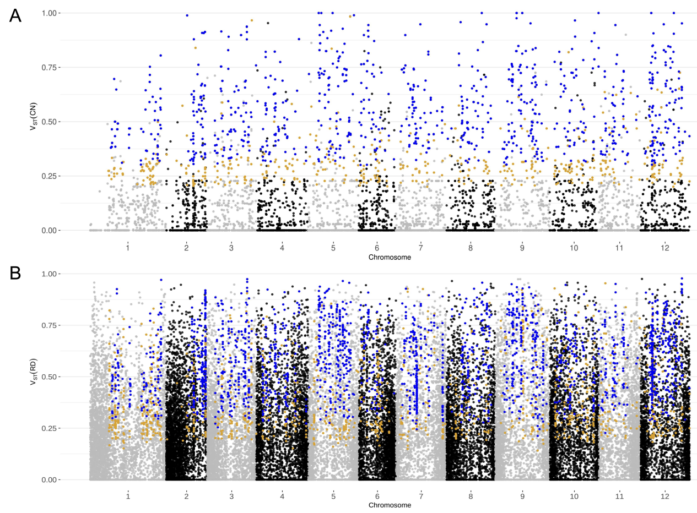

**Fig. S5.** The identification of the differentiated genes based on VST(CN) (A) and VST(RD) (B) using gene copy number (CN) quantified by Control-FREEC and Read Depth, respectively. The orange dots denote the CN-differentiated genes based on the 95th percentile from the distribution obtained with the permutation test (1,000 times), the blue dots denote the strongly CN-differentiated genes based on the 99th percentile from the distribution obtained with the permutation test (1,000 times). The dots represent genes.



**Fig. S6.** The number of copy number (CN) differentiated genes overlapping with deletion (DEL) and duplication (DUP) regions in seven populations.



**Fig. S7.** The PCA based on the gene copy number (CN) values of different gene sets in 35 individuals of seven populations. (A) The PCA based on the CN values of 23,911 genes with mapped reads in 35 individuals. (B) The PCA based on the CN values of 12,392 genes with VST(CN) > 0. (C) The PCA based on the CN values of 2,192 strongly differentiated genes (see Table S5).

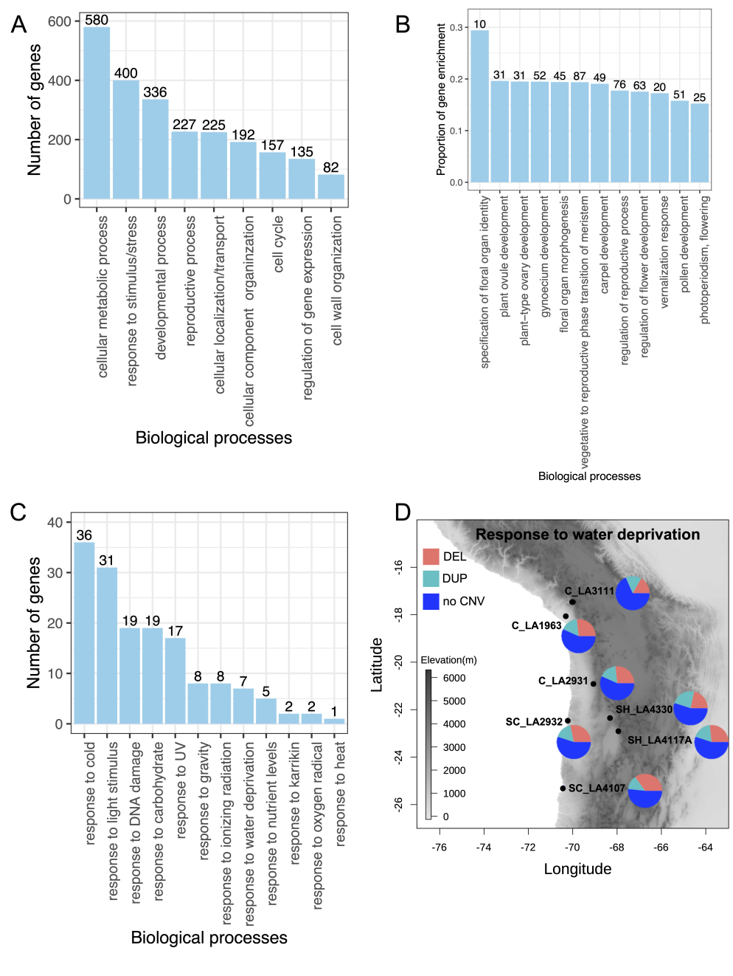

**Fig. S8.** GO enrichment analysis of 3,539 copy number (CN) differentiated genes. (A) The summary of GO enrichment. All significantly enriched GO terms (*P* < 0.05) were assigned into nine categories. (B) The proportions of differentiated genes enriched in different reproductive processes. The proportion of gene enrichment is equal to the number of genes enriched in one GO category divided by the number of background genes in this category. The number on top of each bar represents the number of genes enriched in that GO category. (C) The number of genes associated with the response to external stimulus/stresses overlapping with genes enriched in reproductive process. (D) The 60 CN differentiated genes involved in response to water deprivation with deletion (DEL) and duplication (DUP) in seven populations, respectively. The pie charts denote the number of CN differentiated genes with DEL, DUP or no CNV (see also Table S8).

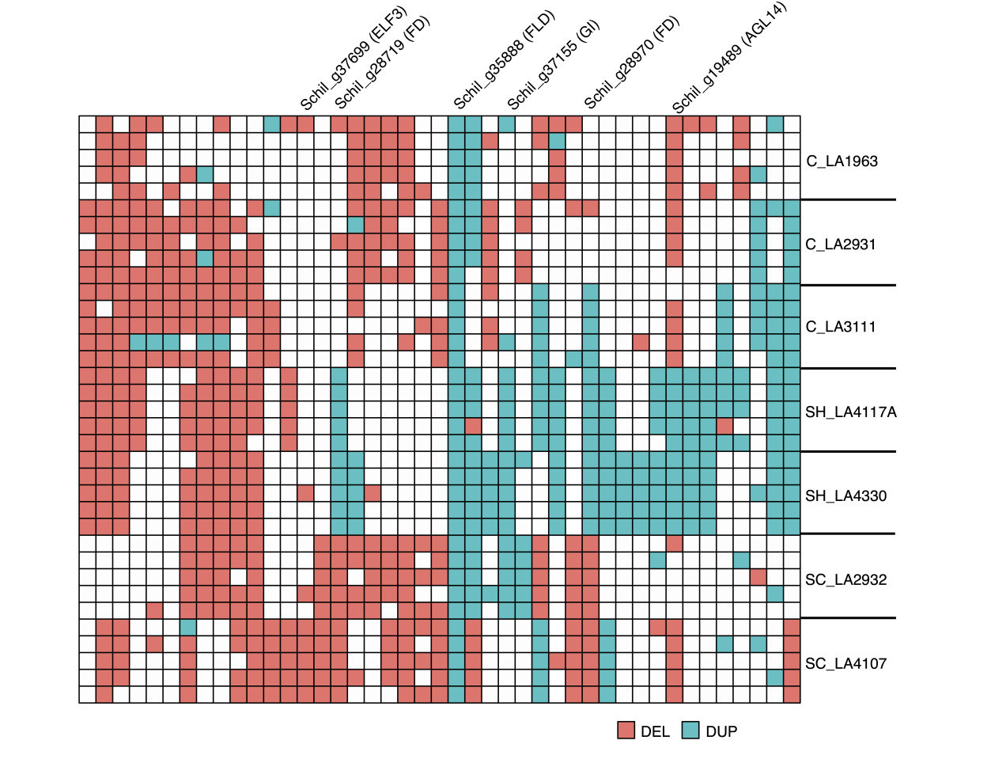

**Fig. S9.** CN-differentiated genes enriched in photoperiod and vernalization pathways show different CNV patterns across seven populations. Putative homologs (see also Dataset S5) are validated as flowering regulatory genes in other plant species named on the top of the matrix. White boxes indicate genes without CNV.

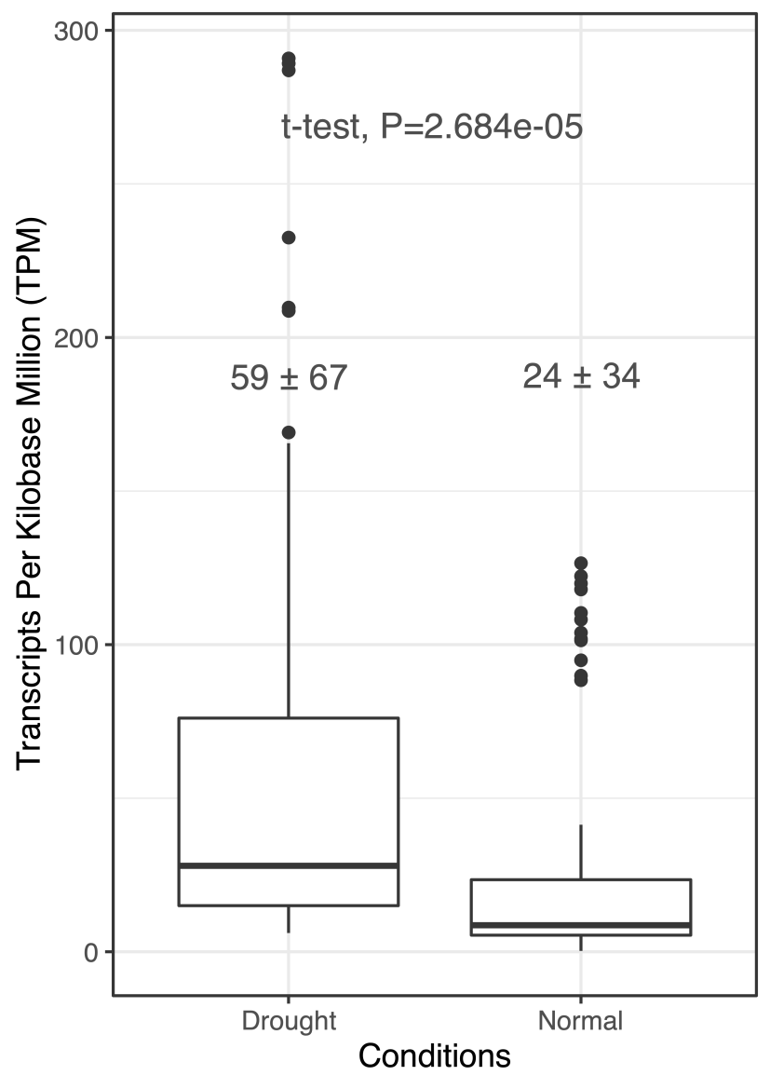

**Fig. S10.** Gene expression of 11 copy number (CN) differentiated genes associated with a response to water deprivation in this study overlapped with drought-responsive genes in metabolic network from the previous study of transcriptomes (Wei et al. 2023a).



**Fig. S11.** The expansion and contraction of the copy number (CN) differentiated genes in different populations using the reference genome of *S. pennellii*.The map and pie charts show that the dynamics of copy number (CN) loss and gain in the processes of two southward colonization events, first to the southern coast (SC) and second to the southern highland (SH) (orange arrows) using the reference genome of *S. pennellii* (see also Table S9).



**Fig. S12.** The PCA based on copy number (CN) of rapidly evolving genes with significant CN expansion or contraction using the reference genome of *S. chilense* (A) and *S. pennellii* (B).

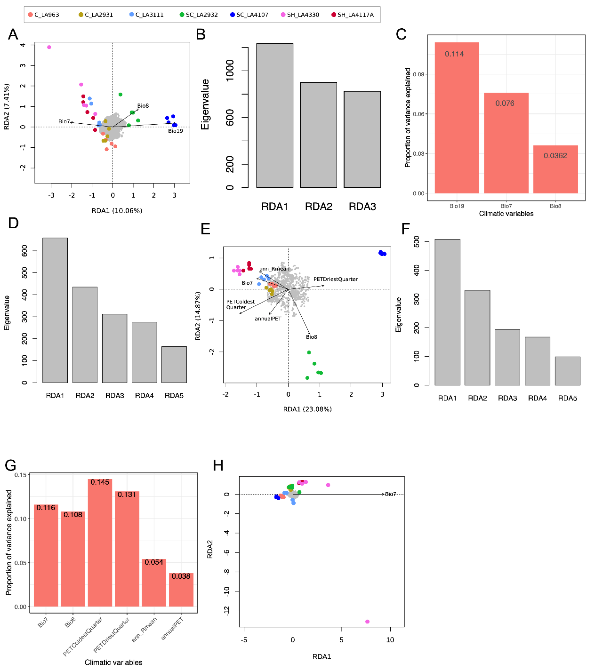

**Fig. S13.** The redundancy analysis (RDA) based on the climatic variables and gene copy number (CN) of the different gene sets. (A) RDA model shows no significant result based on CN of 23,911 genes. (B) RDA model based on CN of 12,391 genes with VST > 0. (C) The eigenvalues of three significant ordination axes in the RDA model based on CN of 12,391 genes with VST > 0. (D) The proportion of variance explained by three overrepresented climate variables in the RDA model based on CN of 12,391 genes with VST > 0. (E) The eigenvalues of five significant ordination axes in an RDA model based on CN of 3,539 differentiated genes. (F) RDA model based on CN of 2,192 strongly differentiated genes. (G) The eigenvalues of five significant ordination axes in RDA model based on CN of 2,192 strongly differentiated genes. (H) The proportion of variance explained by six overrepresented climate variables in RDA model based on CN of 2,192 strongly differentiated genes. In RDA models, arrows indicate the direction of the climatic variables associated with the different populations, and the projection of arrows onto an ordination axis show the correlation with that axis. The grey points denote the CN-differentiated genes. The dots represent individual plants and are colored by population. C: central; SH: southern highland; SC: southern coast.

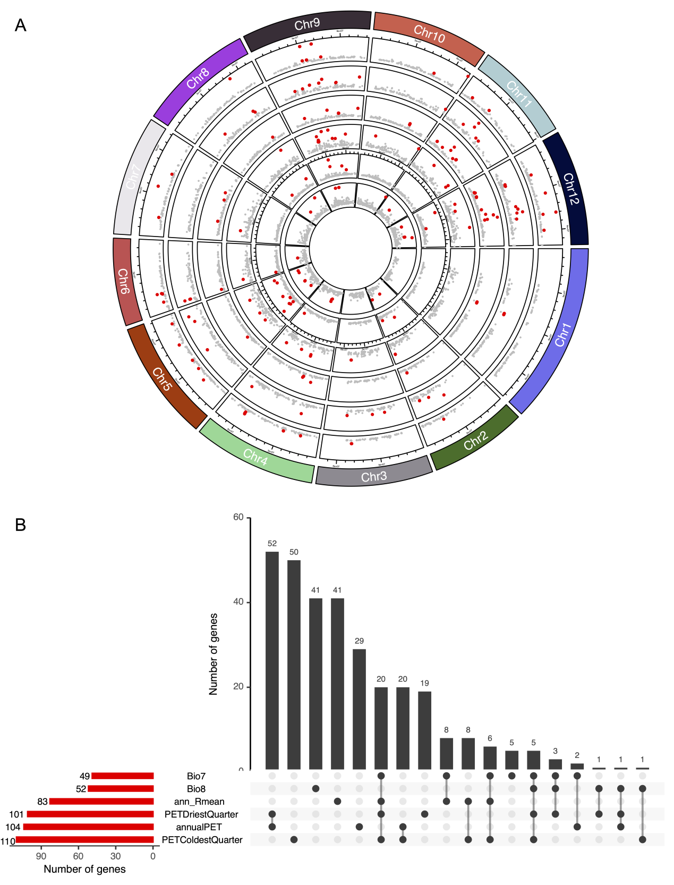

**Fig. S14.** The genome-environment association (GEA) analysis between gene copy number (CN) and the climatic variables using LFMM2. (A) The analyses of gene CN associated with six climatic variables (from inside to outside are Bio7, Bio8, ann_Rmean, PETDriestQuarter, annualPET, PETColdestQuarter) obtained from RDA, respectively. The horizontal axis denotes the position of the gene on the chromosome and the vertical axis denotes the values of -log10(*P*). Red dots represent candidate genes significantly associated with specific climate variables. (B) The number of candidate genes associated with six climatic variables (red bar), respectively, and shared candidate genes across climatic variables (black bar).



**Fig. S15.** The summary of candidate genes associated with the climatic variables. (A) PCA based on the copy number (CN) of 312 candidate genes identified by LFMM2 as being associated with six climatic variables. (B) The number of candidate genes identified by LFMM2 located at duplication (DUP) regions in seven populations. (C) The number of candidate genes identified by LFMM2 located at deletion (DEL) regions in seven populations.

**Table S1.** The number of deletion (DEL) and duplication (DUP) in each population

|  |  |  |
| --- | --- | --- |
| Populations | DEL | DUP |
| C_LA1963 | 68393 | 26228 |
| C_LA2931 | 66859 | 25970 |
| C_LA3111 | 58859 | 25133 |
| SC_LA2932 | 56914 | 22576 |
| SC_LA4107 | 51849 | 21165 |
| SH_LA4117A | 54314 | 22504 |
| SH_LA4330 | 55661 | 23117 |

**Table S2**. The number of deletion (DEL) and duplication (DUP) in each individual.

|  |  |  |  |  |  |
| --- | --- | --- | --- | --- | --- |
| Groups | Populations | Individuals | DEL | DUP | Total |
| central | C_LA1963 | C_LA1963_t1 | 31891 | 11736 | 43627 |
| central | C_LA1963 | C_LA1963_t2 | 28596 | 10605 | 39201 |
| central | C_LA1963 | C_LA1963_t5 | 31627 | 11908 | 43535 |
| central | C_LA1963 | C_LA1963_t7 | 29069 | 10913 | 39982 |
| central | C_LA1963 | C_LA1963_t9 | 31312 | 11679 | 42991 |
| central | C_LA2931 | C_LA2931_t2 | 30586 | 11342 | 41928 |
| central | C_LA2931 | C_LA2931_t3 | 30871 | 11334 | 42205 |
| central | C_LA2931 | C_LA2931_t4 | 31676 | 11809 | 43485 |
| central | C_LA2931 | C_LA2931_t5 | 32074 | 11730 | 43804 |
| central | C_LA2931 | C_LA2931_t6 | 31133 | 11556 | 42689 |
| central | C_LA3111 | C_LA3111_t3 | 28357 | 11789 | 40146 |
| central | C_LA3111 | C_LA3111_t5 | 30898 | 12507 | 43405 |
| central | C_LA3111 | C_LA3111_t9 | 25406 | 10597 | 36003 |
| central | C_LA3111 | C_LA3111_t10 | 27963 | 11594 | 39557 |
| central | C_LA3111 | C_LA3111_t15 | 27623 | 11765 | 39388 |
| southern coast | SC_LA2932 | SC_LA2932_1 | 34249 | 12330 | 46579 |
| southern coast | SC_LA2932 | SC_LA2932_8 | 31684 | 11379 | 43063 |
| southern coast | SC_LA2932 | SC_LA2932_t2 | 32097 | 11514 | 43611 |
| southern coast | SC_LA2932 | SC_LA2932_20 | 31230 | 11074 | 42304 |
| southern coast | SC_LA2932 | SC_LA2932_22 | 30155 | 10765 | 40920 |
| southern coast | SC_LA4107 | SC_LA4107_3 | 30991 | 11103 | 42094 |
| southern coast | SC_LA4107 | SC_LA4107_6 | 33141 | 12096 | 45237 |
| southern coast | SC_LA4107 | SC_LA4107_9 | 32849 | 11761 | 44610 |
| southern coast | SC_LA4107 | SC_LA4107_t5 | 31243 | 11456 | 42699 |
| southern coast | SC_LA4107 | SC_LA4107_t11 | 30818 | 11006 | 41824 |
| southern highland | SH_LA4117A | SH_LA4117A_1 | 27913 | 9391 | 37304 |
| southern highland | SH_LA4117A | SH_LA4117A_4 | 28128 | 10452 | 38580 |
| southern highland | SH_LA4117A | SH_LA4117A_5 | 28858 | 9865 | 38723 |
| southern highland | SH_LA4117A | SH_LA4117A_10 | 27772 | 10131 | 37903 |
| southern highland | SH_LA4117A | SH_LA4117A_15 | 24905 | 7018 | 31923 |
| southern highland | SH_LA4330 | SH_LA4330_t1 | 29186 | 11019 | 40205 |
| southern highland | SH_LA4330 | SH_LA4330_t4 | 32217 | 12281 | 44498 |
| southern highland | SH_LA4330 | SH_LA4330_t6 | 26220 | 9823 | 36043 |
| southern highland | SH_LA4330 | SH_LA4330_t9 | 31562 | 11964 | 43526 |
| southern highland | SH_LA4330 | SH_LA4330_t12 | 30934 | 11610 | 42544 |

**Table S3.** The validation of pipeline of CNV calling using 1,000 simulated deletions (DELs) and duplications (DUPs), respectively.

|  |  |  |
| --- | --- | --- |
| CNV caller | Number of DEL | Number of DUP |
| Lumpy | 878 (21) | 842(13) |
| Manta | 795 (29) | 774(36) |
| Wham | 767 (33) | 698 (19) |
| Delly | 849 (40) | 861 (22) |
| SURVIVOR merged | 918(12) | 879 (4) |

**Table S4.** The measures of population differentiation based on copy number (VST(RD) and VST(CN)) and SNPs (FST).

|  |  |  |  |  |
| --- | --- | --- | --- | --- |
| Pairwise populations | VST(RD) | VST(CN) | *F*ST | *D*xy |
| C_LA1963 vs C_LA2931 | 0.090 ±0.153 | 0.070±0.125 | 0.074±0.131 | 0.111±0.050 |
| C_LA1963 vs C_LA3111 | 0.123±0.177 | 0.082±0.138 | 0.097±0.146 | 0.139±0.051 |
| C_LA2931 vs C_LA3111 | 0.131±0.194 | 0.095±0.162 | 0.139±0.155 | 0.122±0.050 |
| SH_LA4117A vs SH_LA4330 | 0.217±0.239 | 0.108±0.188 | 0.178±0.247 | 0.136±0.054 |
| C_LA3111 vs SH_LA4330 | 0.137±0.212 | 0.111±0.177 | 0.218±0.227 | 0.139±0.056 |
| C_LA2931 vs SH_LA4330 | 0.146±0.198 | 0.117±0.165 | 0.150±0.163 | 0.129±0.055 |
| C_LA1963 vs SH_LA4330 | 0.162±0.203 | 0.128±0.190 | 0.143±0.147 | 0.127±0.055 |
| C_LA2931 vs SC_LA2932 | 0.169±0.245 | 0.133±0.134 | 0.224±0.270 | 0.149±0.062 |
| C_LA1963 vs SC_LA2932 | 0.177±0.248 | 0.133±0.174 | 0.211±0.196 | 0.152±0.064 |
| C_LA1963 vs SH_LA4117A | 0.198±0.244 | 0.141±0.189 | 0.156±0.149 | 0.129±0.055 |
| C_LA2931 vs SH_LA4117A | 0.204±0.248 | 0.156±0.206 | 0.164±0.172 | 0.131±0.055 |
| SC_LA2932 vs C_LA3111 | 0.198±0.276 | 0.157±0.196 | 0.286±0.311 | 0.151±0.067 |
| C_LA3111 vs SH_LA4117A | 0.228±0.257 | 0.158±0.218 | 0.231±0.255 | 0.147±0.057 |
| SC_LA2932 vs SH_LA4330 | 0.208±0.267 | 0.178±0.230 | 0.337±0.382 | 0.169±0.065 |
| SC_LA4107 vs SH_LA4330 | 0.243±0.291 | 0.185±0.259 | 0.392±0.431 | 0.195±0.067 |
| C_LA1963 vs SC_LA4107 | 0.215±0.272 | 0.192±0.236 | 0.252±0.277 | 0.178±0.067 |
| C_LA2931 vs SC_LA4107 | 0.211±0.275 | 0.192±0.244 | 0.274±0.278 | 0.156±0.064 |
| SC_LA2932 vs SC_LA4107 | 0.200±0.281 | 0.192±0.254 | 0.331±0.337 | 0.159±0.070 |
| SC_LA2932 vs SH_LA4117A | 0.278±0.300 | 0.192±0.259 | 0.350±0.414 | 0.150±0.064 |
| C_LA3111 vs SC_LA4107 | 0.229±0.284 | 0.193±0.262 | 0.333±0.401 | 0.178±0.070 |
| SC_LA4107 vs SH_LA4117A | 0.298±0.315 | 0.238±0.287 | 0.407±0.448 | 0.216±0.067 |

**Table S5.** The number of candidate genes with differentiated gene CN across seven populations

|  |  |  |  |  |
| --- | --- | --- | --- | --- |
| VST | Differentiated (95th percentile) | | Strongly differentiated (99th percentile) | |
| Threshold | Number of genes | Threshold | Number of genes |
| VST(CN) | 0.194 | 4,843 | 0.305 | 3,219 |
| VST(RD) | 0.157 | 16,655 | 0.244 | 12,228 |
| Overlaps |  | 3,539 |  | 2,192 |

**Table S6.** The number of CN differentiated genes involved in four GO terms in seven populations located in deletion (DEL) and duplication (DUP) regions.

|  |  |  |  |  |  |  |  |  |  |  |  |  |
| --- | --- | --- | --- | --- | --- | --- | --- | --- | --- | --- | --- | --- |
| Populations | photoperiod | | | vernalization | | | response to water deprivation | | | root development | | |
| DEL | DUP | no CNV | DEL | DUP | no CNV | DEL | DUP | no CNV | DEL | DUP | no CNV |
| C_LA1963 | 6 | 1 | 18 | 8 | 1 | 11 | 16 | 10 | 34 | 26 | 17 | 30 |
| C_LA2931 | 10 | 1 | 14 | 9 | 3 | 8 | 16 | 10 | 34 | 12 | 4 | 57 |
| C_LA3111 | 8 | 2 | 15 | 7 | 5 | 8 | 10 | 9 | 41 | 11 | 8 | 54 |
| SC_LA2932 | 10 | 2 | 13 | 7 | 2 | 11 | 17 | 10 | 33 | 27 | 18 | 28 |
| SC_LA4107 | 9 | 2 | 14 | 10 | 1 | 9 | 21 | 8 | 31 | 25 | 18 | 30 |
| SH_LA4117A | 5 | 8 | 12 | 5 | 8 | 7 | 16 | 11 | 33 | 14 | 7 | 52 |
| SH_LA4330 | 4 | 10 | 11 | 4 | 7 | 9 | 13 | 14 | 33 | 12 | 6 | 55 |

**Table S7.** The summary of CN expansion and contraction in different branches/populations using the reference of *S. pennellii*.

|  |  |  |  |  |  |  |
| --- | --- | --- | --- | --- | --- | --- |
| Groups/Populations | Number of CN expanded genes | Number of CN contracted genes | Number of CN gained | number of CN contracted | aRate of average expansion/  contraction | bNumber of rapidly evolving genes |
| inland | 63 | 48 | 344 | 86 | 2.324 | 28(+21/-7) |
| Central (C) | 186 | 568 | 427 | 937 | -0.676 | 35(+15/-20) |
| southern highland (SH) | 522 | 384 | 1506 | 648 | 0.947 | 51(+38/-13) |
| southern coast (SC) | 67 | 115 | 184 | 211 | -0.1483 | 11(+4/-7) |
| C_LA1963 | 149 | 456 | 322 | 851 | -0.874 | 27(+9/-18) |
| C_LA2931 | 116 | 292 | 360 | 587 | -0.556 | 14(+3/-11) |
| C_LA3111 | 215 | 374 | 762 | 646 | 0.197 | 19(+11/-8) |
| SH_LA4117A | 627 | 484 | 2007 | 824 | 1.065 | 54(+39/-15) |
| SH_LA4330 | 471 | 304 | 1340 | 588 | 0.970 | 43(+43/-0) |
| SC_LA2932 | 215 | 559 | 747 | 1035 | -0.372 | 17(+5/-12) |
| SC_LA4107 | 384 | 306 | 1132 | 692 | 0.638 | 38(+26/-12) |

aRate of average expansion / contraction = (Number of CN gains - Number of CN losses) / (Number of CN expanded genes + Number of CN contracted genes). Positive values indicate CN expansion and negative values indicate CN contraction.

bThe rapidly evolving genes indicate significant higher CN expansion or contraction (*P* values were obtained by the Viterbi method with the randomly generated likelihood distribution; *P* < 0.05) across the different groups/populations. Values outside parentheses represent the total number of the rapidly evolving genes. Positive values in parentheses denote the number of significantly expanded genes and negative values denote the number of significantly contracted genes.

**Table S8.** The number of CN gains (positive values) and CN losses (negative values) for rapidly evolving genes related to photosynthesis in different subgroups representing four different habitats.

|  |  |  |  |  |  |  |
| --- | --- | --- | --- | --- | --- | --- |
| Genes | Central | Southern highland | | SC_LA2932 | | SC_LA4107 |
| Schil_g10783 | - | 19 | - | | - | |
| Schil_g12727 | - | - | - | | 15 | |
| Schil_g13768 | - | - | -6 | | - | |
| Schil_g16334 | -20 | 25 | -21 | | 21 | |
| Schil_g16755 | - | 9 | - | | - | |
| Schil_g17486 | -5 | - | - | | - | |
| Schil_g17837 | -18 | 19 | -17 | | 21 | |
| Schil_g17839 | -18 | 19 | -17 | | 21 | |
| Schil_g17842 | -18 | 19 | -17 | | 21 | |
| Schil_g18042 | - | - | - | | 16 | |
| Schil_g19313 | -5 | 16 | -7 | | - | |
| Schil_g28833 | - | 9 | - | | - | |
| Schil_g29254 | -10 | 16 | -11 | | 10 | |
| Schil_g34328 | -14 | 14 | -17 | | 20 | |
| Schil_g34329 | -14 | 14 | -17 | | 20 | |
| Schil_g38065 | - | 7 | - | | - | |

**Table S9.** The number of CN-differentiated genes associated with temperature annual range (Bio7) and solar radiation (ann_Rmean) in seven populations located in deletion (DEL) and duplication (DUP) regions.

|  |  |  |  |
| --- | --- | --- | --- |
| Populations | DEL | DUP | no CNV |
| C_LA1963 | 7 | 1 | 26 |
| C_LA2931 | 6 | 3 | 25 |
| C_LA3111 | 2 | 1 | 31 |
| SC_LA2932 | 7 | 2 | 25 |
| SC_LA4107 | 10 | 1 | 23 |
| SH_LA4117A | 2 | 5 | 27 |
| SH_LA4330 | 6 | 6 | 22 |